Report: A2 Planet in Space

LEE SUNG JAE

2016314718

Mathematics Department

1. Ideas

In this assignment, I had to define the vertices and indices of the unit sphere by myself. As recommended on 『a2-planet-in-space.pdf』 file, I used 36 edges along the longitude and 72 edges along the latitude, which means that there are 73 columns of 37 vertices with every starting vertex at the south pole, every ending vertex at the north pole, and the starting and the ending longitude overlapped. I noticed that each vertex can form 2 triangles as it becomes the starting vertex. Consider **Fig1**.

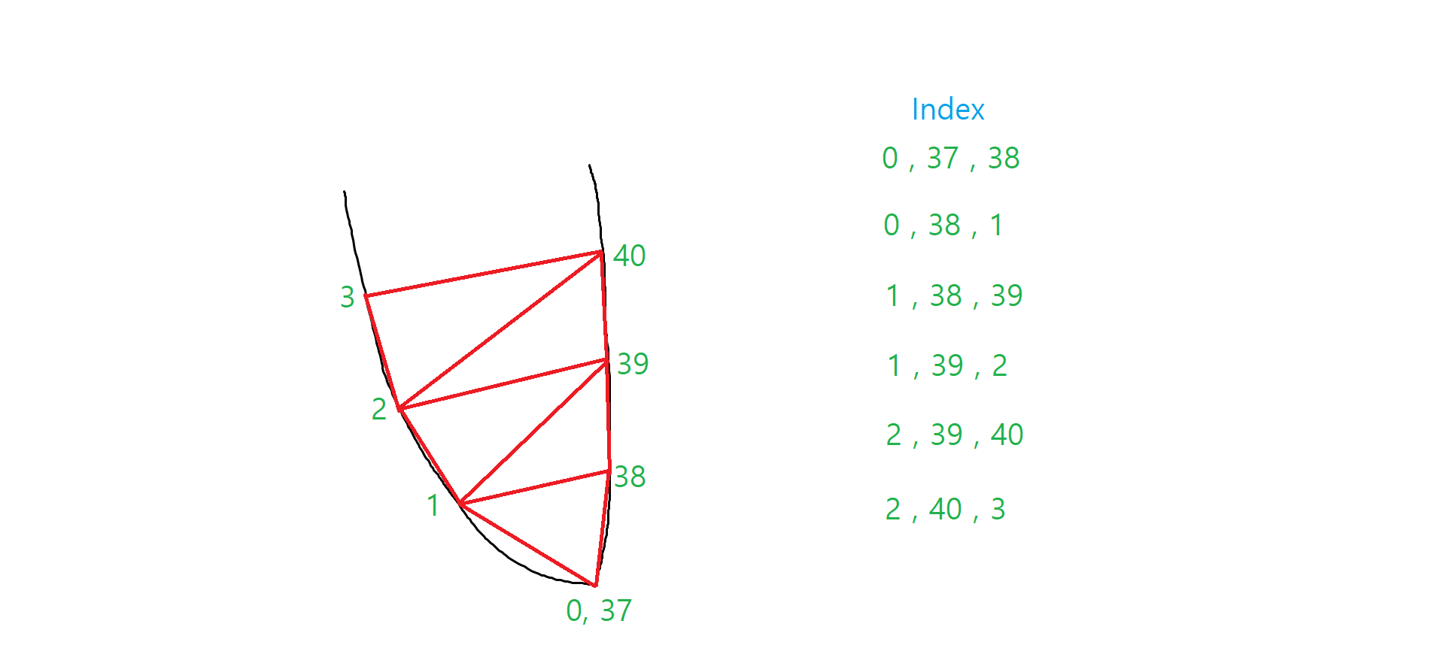

**(Fig1. Example of vertices and indices of a unit sphere at South pole)**

For example, 2 triangles formed by the vertex number 1 are the Triangle(1, 38, 39) and Triangle(1, 39, 2). If I use the same technique at the poles, it does not form any triangle. For example, at the south pole, Index(0, 37, 38) is not a triangle but a line. However, this technique preserves the regularity of forming 2 triangles. Hence, I just ignored the lines at the poles but maintained the regularity. I adapted this technique for 72 longitude lines for every 36 vertices in each longitude line.

The next thing to consider is how to rotate the sphere smoothly. That means the sphere should not change its rotation angle dramatically when it starts rotating again after long stop. This can be done by calculating the elapsed time only when it is rotating. Then, this elapsed time becomes the standard of the theta value of the rotation matrix around z-axis.

1. Implementation

The assignment was begun based on cg-transform and cg-circle codes. I made up vertices and indices of the unit sphere at the beginning of the main() function. This was done by 2 nested loops, one for vertices and the other for indices. For the world transformation, only the rotation matrix was adapted and others were left as identity matrices since the sphere only rotates around z-axis at the same place. For the viewport and projection transformation, the matrix explained on 『a2-planet-in-space.pdf』 was used. To toggle among (tc.xy,0,1), (tc.xxx,1), and (tc.yyy,1) colors, I sent an unsigned integer value to vertex shader and fragment shader which denotes what color should be used. The color can be decided on fragment shader by if-statement.